**PROJECT REPORT**

**On**

**Flood Detection System**

(CSE III Semester Mini Project PCS-504)

2020-2021



**Submitted to: Submitted by:**

Mr. Umang Garg Muskan Janweja

(CC-CSE-A-III-SEM) Roll No.: 56

1918493 CSE-B-III-SEM

**Guided by:** Session: 2020-2021

Dr. Vrince Vimal

DEPARTMENT OF COMPUTER SCIENCE AND INFORMATION TECHNOLOGY

GRAPHIC ERA HILL UNIVERSITY, DEHRADUN

**CERTIFICATE**

Certified that Mr. Muskan Janweja (Roll No.: 1918493) has developed mini project on “Flood Detection System” for the CS III Semester Mini Project Lab (PCS-504) in Graphic Era Hill University, Dehradun. The project carried out by students is their own work as best of my knowledge.

Date: 28.11.2020

(Mr. Umang Garg) Muskan Janweja

**Project Co-ordinator Project Guide**

CC-CSE-A-III-Sem Mr. Vrince Vimal

(CSE DEPARTMENT) (CSE DEPARTMENT)

GEHU Dehradun GEHU Dehradun

**ACKNOWLEDGEMENT**

We would like to express our gratitude to The Almighty Shiva Baba, the most Beneficent and the most Merciful, for completion of project.

We wish to thank our parents for their continuing support and encouragement. We also wish to thank them for providing us with the opportunity to reach this far in our studies.

We would like to thank particularly our project Co-ordinator Mr. Umang Garg and our project Guide Mr. Vrince Vimal for his patience, support and encouragement throughout the completion of this project and having faith in us.

We also acknowledge to teachers like Dr. Vrince Vimal and Mr. Umang Garg who help us in developing the project.

At last but not the least we greatly indebted to all other persons who directly or indirectly helped us during this work.

MUSKAN JANWEJA

Roll No.: 1918493

CSE-A-III-Sem

Session: 2020-2021

GEHU, Dehradun

**TABLE OF CONTENTS**

**CHAPTER NO. TITLE PAGE NO.**

1. **INTRODUCTION 3**

1. ABOUT PROJECT **4**
2. ABOUT INTERNET OF THINGS **4**
3. LITERATURE REVIEW **5**
4. OBJECTIVE OF THE STUDY **5**
5. **PROJECT**

1. REQUIREMENT ANALYSIS **5**
2. SOFTWARE SPECIFICATION **10**
3. DIAGRAMS **10**
4. APPLICATIONS **12**
5. ADVANTAGES AND ENHANCEMENTS **12**
6. **SNAPSHOTS OF THE PROJECT**
7. Figure 1 **13**
8. FIGURE 2 **13**
9. **CONCLUSION**

1. SUMMARY **14**
2. CONCLUSION **14**
3. FUTURE WORKS **14**

**APPENDIX:** CODE **15**

**REFERENCE 17**

**CHAPTER 1**

**INTRODUCTION**

* 1. **ABOUT PROJECT**

Flood occurs when water overflows from the river, lake or from heavy rainfall and it can happen at any time of the year. Flooding can be very dangerous, when floods happen in an area that people live, the water carries along objects like houses, cars, furniture and even people. It can wipe away property, trees and many more heavy items.

In a large portion of the developing nations, flood checking cell are not legitimately outfitted with savvy and versatile flood distributing framework. Therefore, individuals from flood influenced zones are enduring the results of flood each year. This catastrophic event can’t be escaped anyway suitable overseeing and pre-disturbing system can lessen in reality. The main objective of this project is to develop and design a “Flood Detection System” that will detect flood automatically and transmits data through IOT.

Floods are basic catastrophic events that allows extreme desolation of any nation. They are typically brought about by precipitation and overflow of waterways, especially during heavy stormy season. This project aims to monitor the flood condition and send alert if there is an occurrence of risk through IOT. The measurement of rising water level is done to detect temperature, humidity and water levels at every stage. The detected sensor values are processed using PIC Microcontroller and it is transmitted to IOT through Wi-Fi module. The system instantaneously uploads and broadcasts sensor values through cloud.

This system used to detect the current water level of flood around the road and give real-time information through the flooded area to avoid problem. The Arduino Flood Detector System is developed to be one of the fastest method to monitor flood that will help user to avoid problem when flood occurred.

* 1. **ABOUT INTERNET OF THINGS**

IOT architecture represents a functional hierarchy of how information is disseminated across layers between devices which contain sensing and actuating capabilities and massive data centres (cloud storage). The IOT architecture and the interactions between the respective layers: sensor and actuator, device, gateway and cloud. The base of the architectural stack consists of sensors and actuators that gathers information from the physical world (via sensors) and manipulates it while interacting with the device layer.

The device layer aggregates data from sensors and forward to the gateway layer. The gateway layer routes and forwards this data collected from the device layer to the cloud layer for storage and processing. Resource constraints decrease up the architectural stack, with the cloud layer having the most resources (memory, power, computation), and the sensor-actuator layer having the least.

In any of the IOT architecture, storage of the data either locally or on the cloud , it could be either local storage or it could be cloud storage. So, this is the second element which is a part of the architecture. The third one perhaps once you have rested the data, push the data, stored the data, the data is in the resting condition you want to act on the data and perform another important block called the data analytics. So, this is the third block. The fourth block of our architecture which clearly indicates that when you perform actions according to the data received to make the system work properly.

* 1. **LITERATURE REVIEW**

Researchers and engineers in the world have taken various approaches to the design of a flood management system. Since in our case, we use wireless electronic gages, with a wireless communication module capable of transmitting acquired data queue service. This not only helps reduce the cost of implementation, but also enhances maintainability due to the low power requirement of on-field sensor module. Through, this approach allows the sensors to be deployed at any desired location, the system developed in this project has low power requirements, is more maintainable, and is extremely low-cost. Our system does not follow a multi-tiered approach which should lead to lower latency, and requires lesser resources.

* 1. **OBJECTIVE OF THE STUDY**

The main objective of this project is to develop and design a flood detection system that will detect flood automatically and send data to the registered mobile number and to using an Arduino.

Specific Objectives:

* To design a circuit and create a programming code using the microcontroller (Arduino).
* To apply the Serial Communication in transmitting the data from one place to another place.
* To detect the current level of the flood where the system sensor will e divided into different levels.

**CHAPTER 2**

**PROJECT**

**2.1 REQUIREMENT ANALYSIS**

Different hardware used in our projects are:

* **ARDUINO UNO (R3)**

The Arduino UNO is the heart of the system and all the sensors are connected to the Arduino. It consists of 14-digital I/O pins, where 6-pins can be used as PWM(Pulse Width Modulation Output), 6-analog inputs, a reset button, a power jack, a USB connection and more. It includes everything required to hold up the microcontroller, simply attach it to a PC with the help of a USB cable and give the supply to get started with a AC-to-DC adapter or battery.

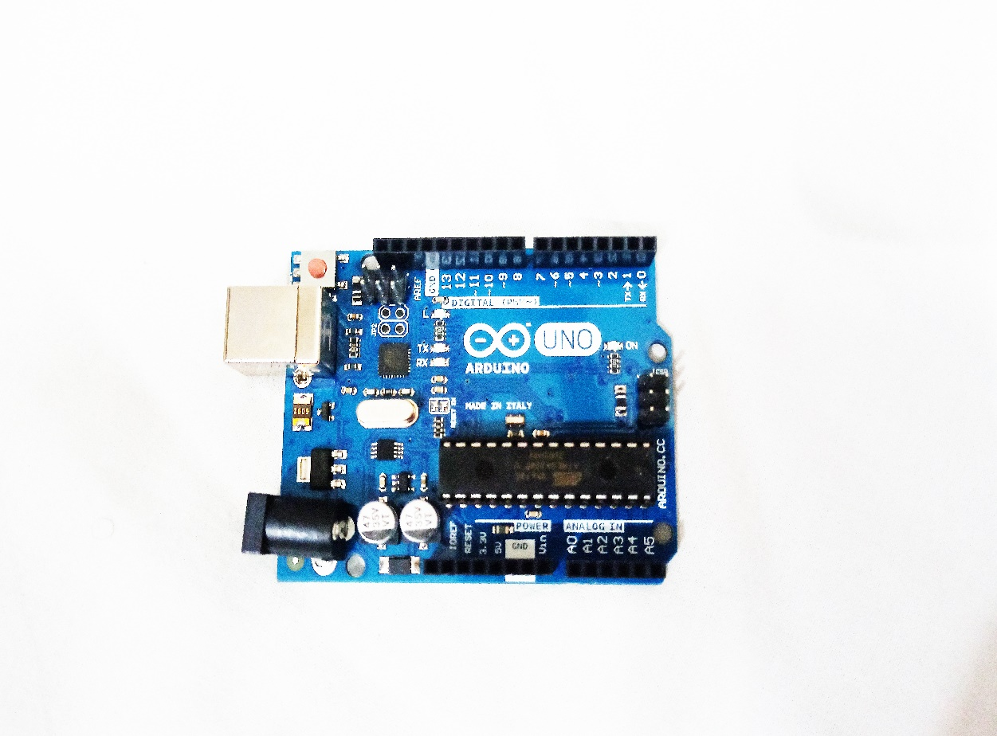

* **WATER LEVEL SENSOR**

Water level sensors are used to detect the level of substances that can flow. Such measurements can be used to determine the amount of materials within a closed container or the flow of water in open channels.

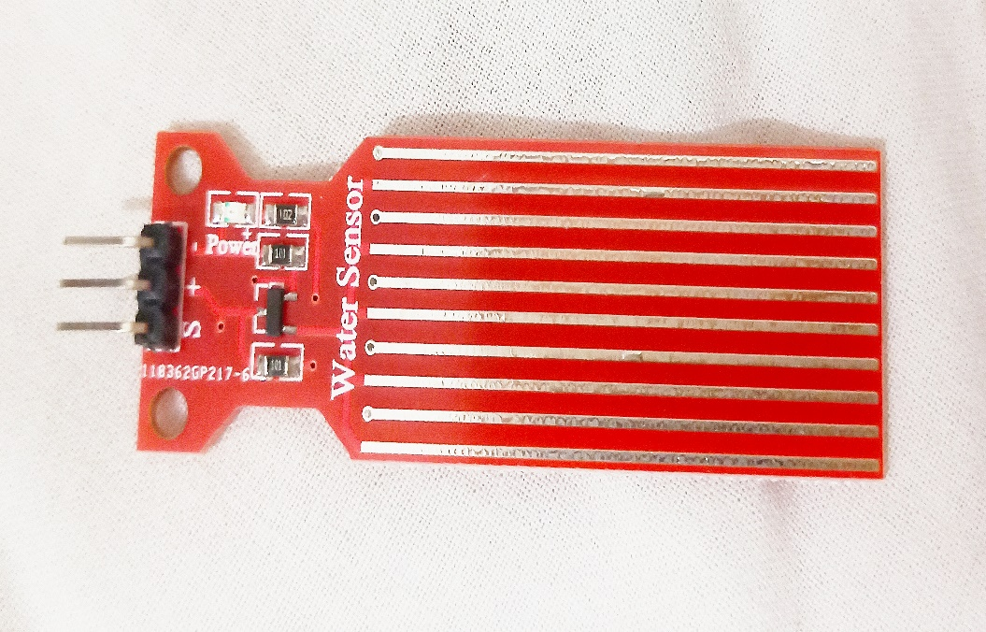

* **HUMIDITY SENSOR**

A Humidity Sensor is a device that detects and measures water vapour. Based on our robust capacitive technology, these humidity sensors provide accurate measurement of dew point and absolute humidity by combining relative humidity and temperature measurements.

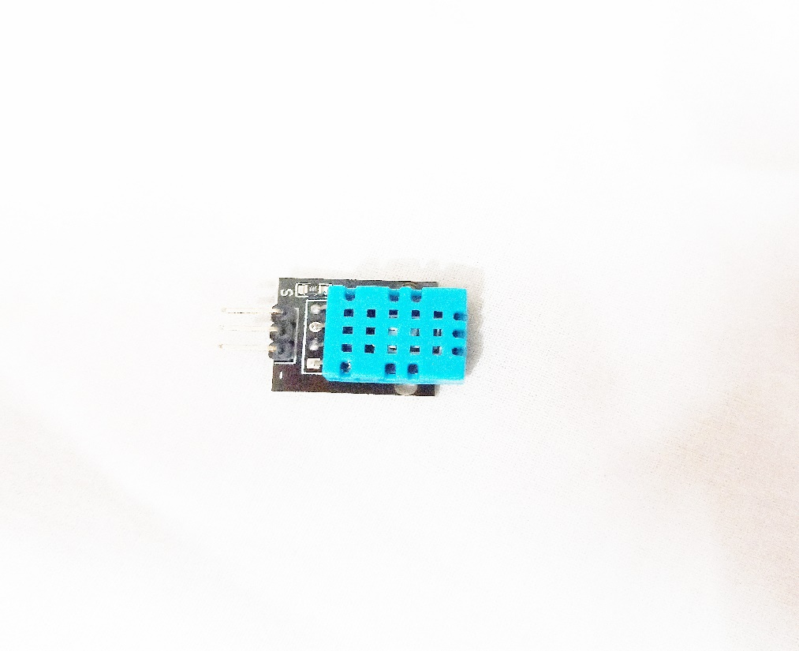

* **LM35 TEMPERATURE SENSOR**

LM35 is a precession Integrated circuit Temperature sensor, whose output voltage varies, based on the temperature around it. It is a small and cheap IC which can be used to measure temperature anywhere. There will be rise of 0.01V for every degree Celsius rise in temperature.

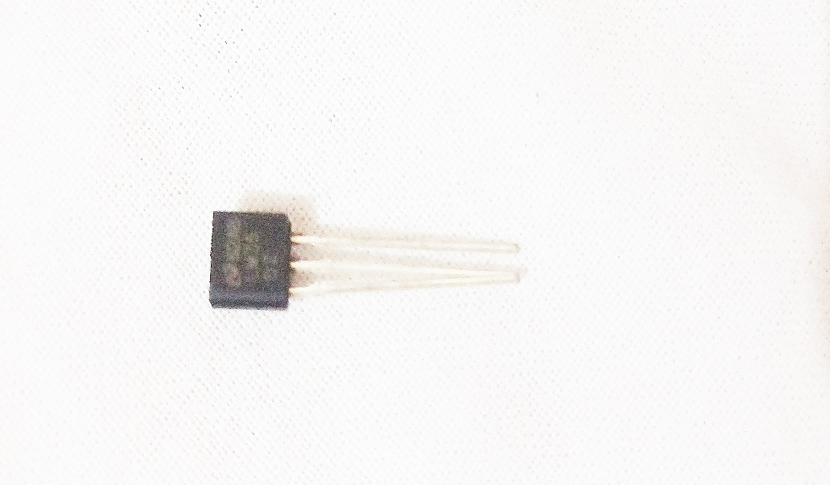

* **LCD DISPLAY**

A liquid-crystal display (LCD) is a flat-panel display or other electronically modulated optical device that uses the light-modulating properties of liquid crystals combined with polarizers. Liquid crystals do not emit light directly, instead using a backlight or reflector to produce images in colour or monochrome.

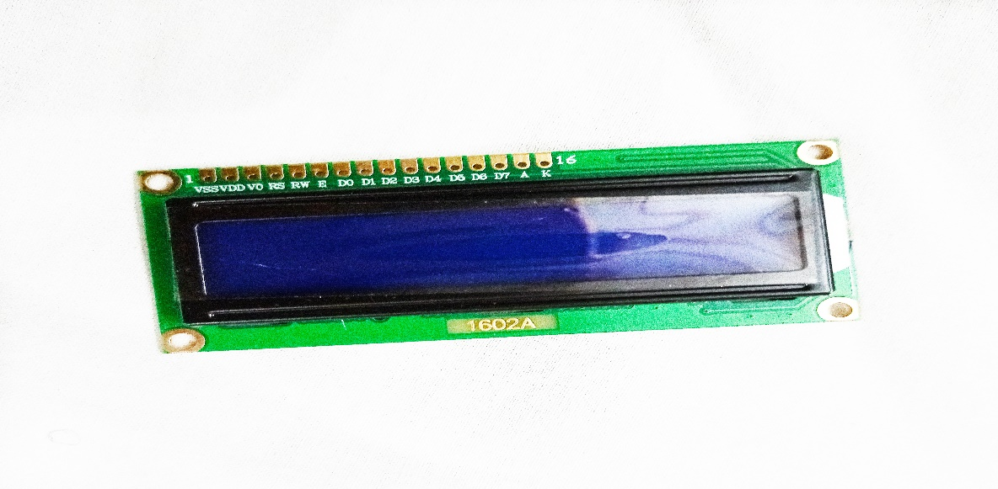

* **BUZZER**

A buzzer is an audio signalling device, which may be mechanical, electromechanical, or piezoelectric. Typical uses of buzzers include alarm devices, timers, and confirmation of user input such as a mouse click or keystroke.

* **LIGHT-EMITTING DIODE (LED)**

A light-emitting diode (LED) is a semiconductor light source that emits light when current flows through it. The colour of the light is determined by the energy required for electrons to cross the band gap of the semiconductor.

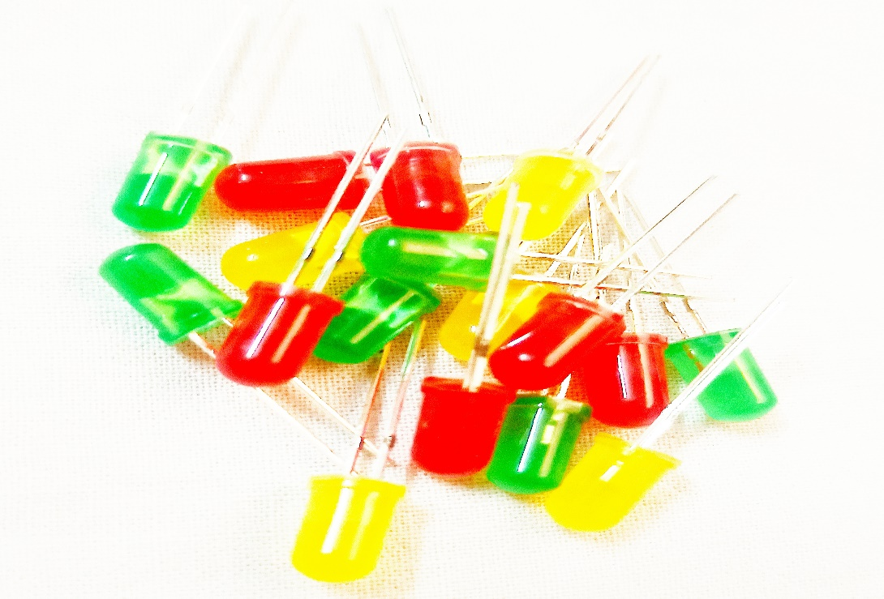

* **MOTOR**

Stepper Motor is a type of brushless DC Motor that converts electrical pulses into distinct mechanical movements i.e. the shaft of a stepper motor rotates in discrete steps.

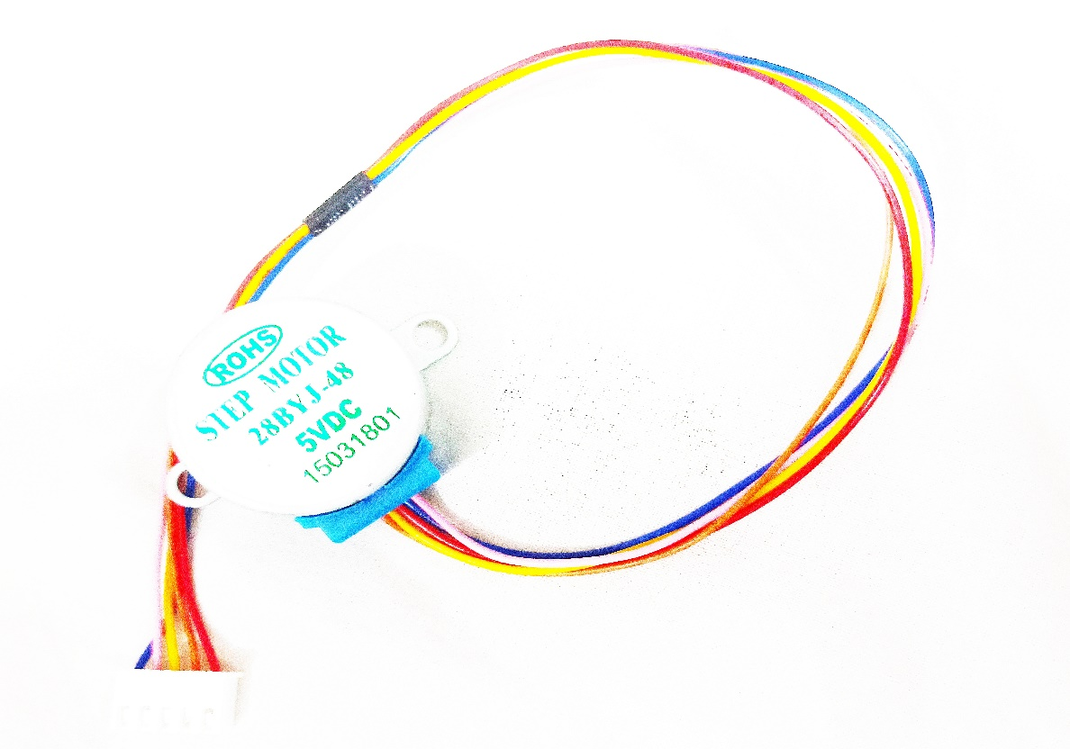

* **9G SERVO**

A Servo is a small device that has an output shaft. Servos are used in radio controlled airplanes to position control surfaces like the elevators and rudders. They are used in radio controlled cars, puppets, and of course, robots.

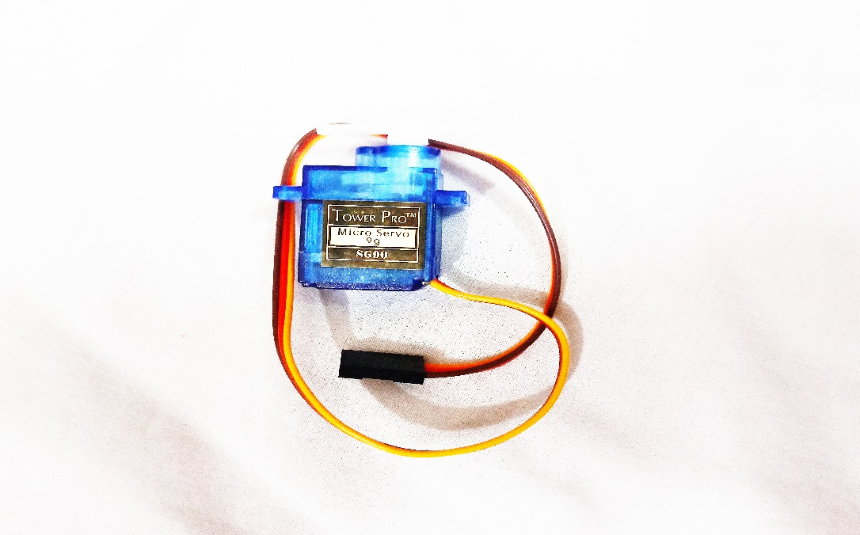

**2.2 SOFTWARE SPECIFICATION**

For software part awe have integrated our system with android we developed an android system that is fully capable of monitoring the system environment.

This is done using the data sent by the system. Using an android app makes it for mobile and convenient to use the app is just one click away. Every detail related to the system can be viewed in this app. It can notify the user if there us any possibility of flood to occur.

For e.g. certain rise in water flow increasing the overall water level of the dam/container (in our case) the application is versatile enough to let the user know about this and report it before hand in order to avoid any form of casualties.

The application can also be used to monitor sensor data in real time. It can be efficiently used by any individual to monitor the system. It is user friendly and avoids complication of different data used as the user is only provided with what really is important.

**2.3 DIAGRAMS**

DIAGRAM REPRESENTING THE ARCHITECTURE OF INTERNET OF THINGS

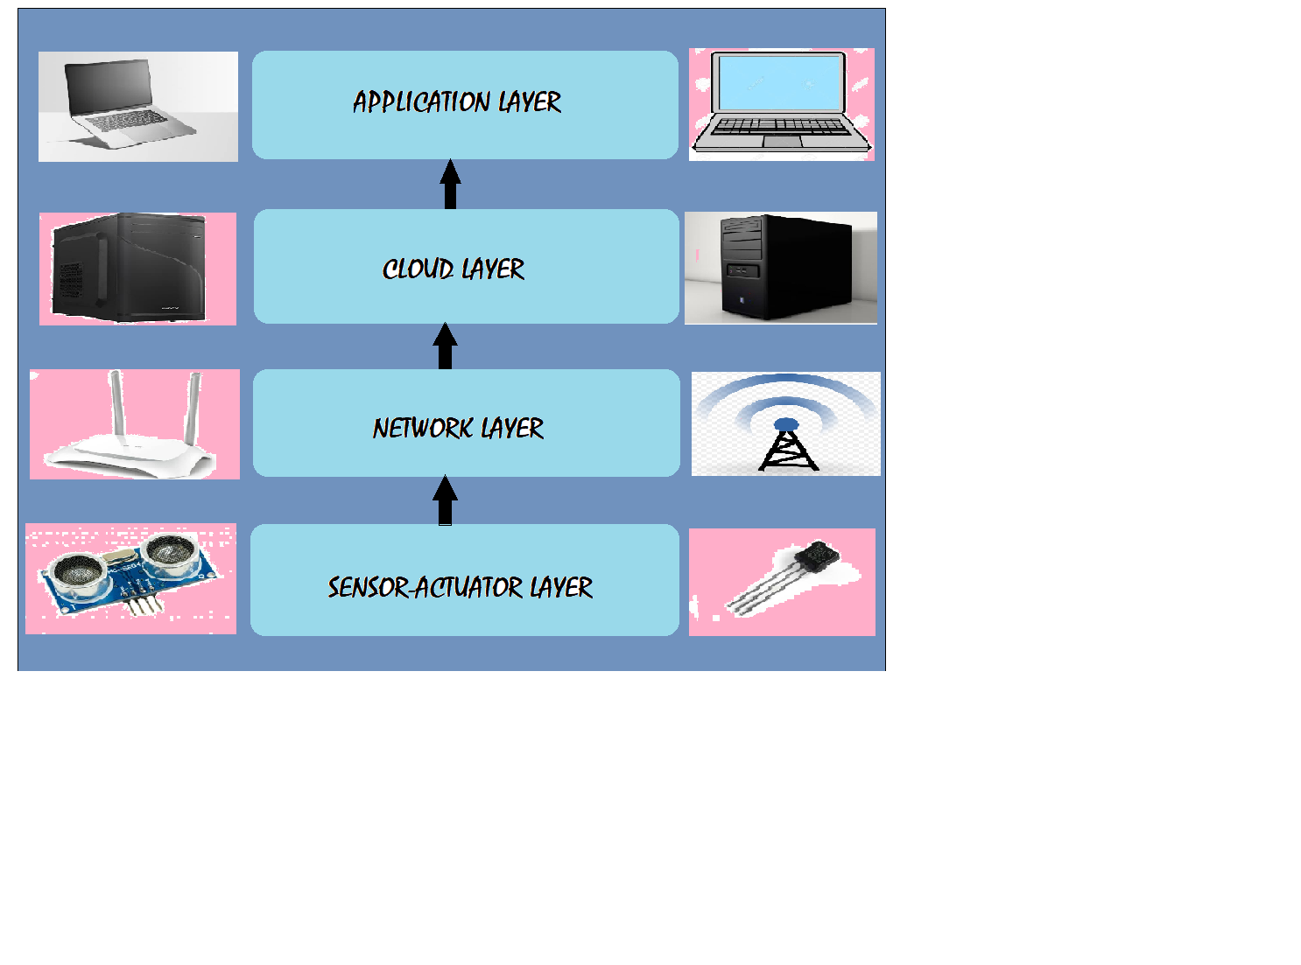BLOCK DIAGRAM REPRESENTING THE COMPONENTS OF FLOOD DETECTION SYSTEM

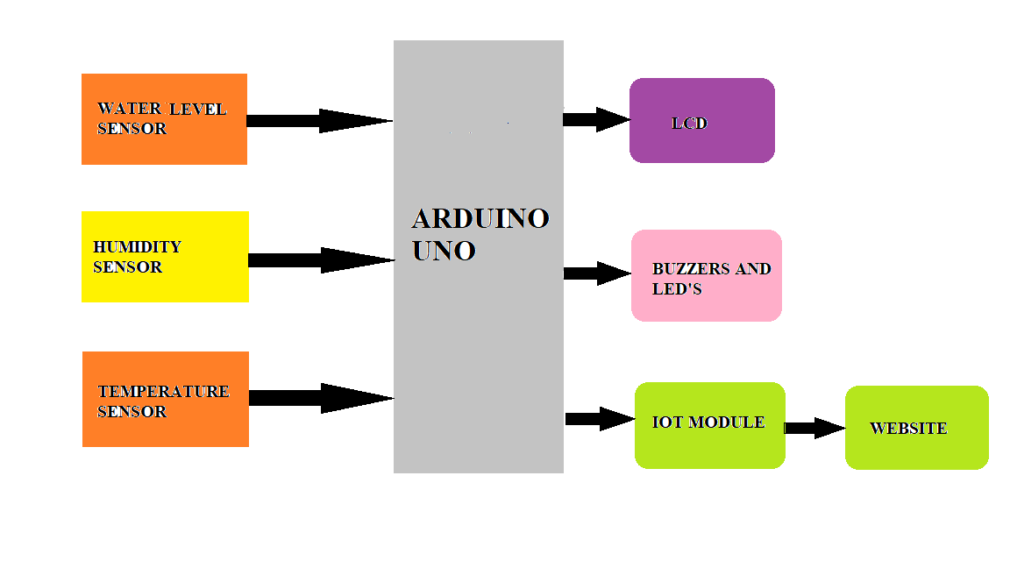

DIAGRAM SHOWING IMPLEMENTATION METHOD

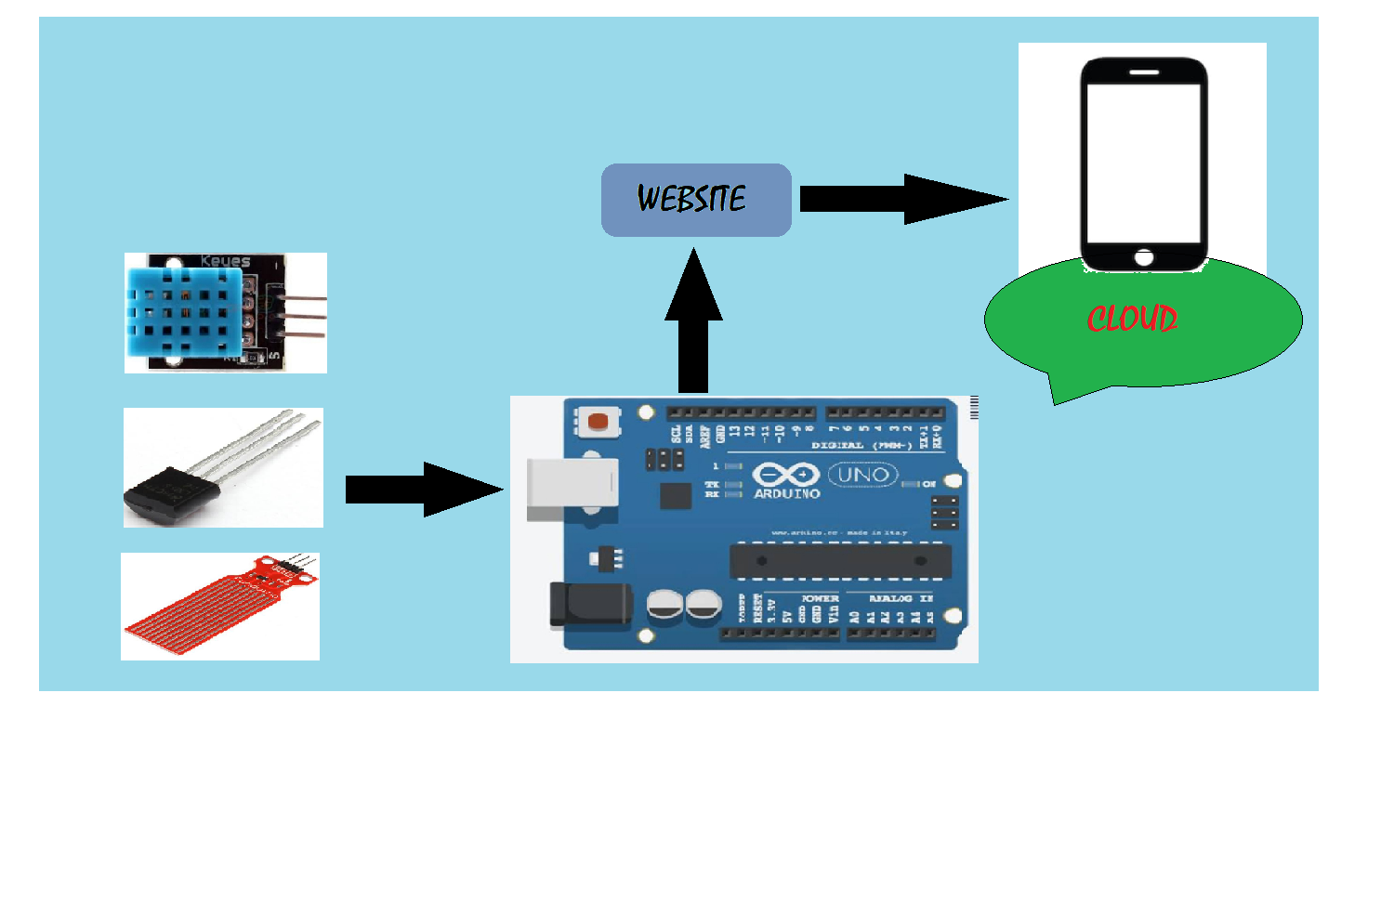

**2.4 APPLICATIONS**

The Project offers tremendous applications, some of which are listed below:

* Monitoring of flood over remote areas.
* Immediate alert of increasing water along the railway tracks to the station master.
* Direct notification to the concerned authorities.
* Fast service is provided which is essential to make people cautious of danger.
* Can also be fitted in the Glacier regions to keep a check on unexpected rapid melting of the glaciers.
* Possibility to feed multiple contacts and reset them using EEPROM.

**2.5 ADVANTAGES AND ENHANCEMENTS**

* The project is constructed with easily available and reasonably priced components and hence provides a cost effective solution for flood detection and avoidance.
* The project is enabled with IOT technology and hence the sensor data can be monitored from anywhere in the world.
* More sensors can be integrated into the system in order to create a more accurate and efficient flood detection system.
* A network of these devices can be constructed to cover a large territory and hence, a disaster management system can be formed on a national or state level.

**CHAPTER 3**

**SNAPSHOTS OF THE PROJECT**

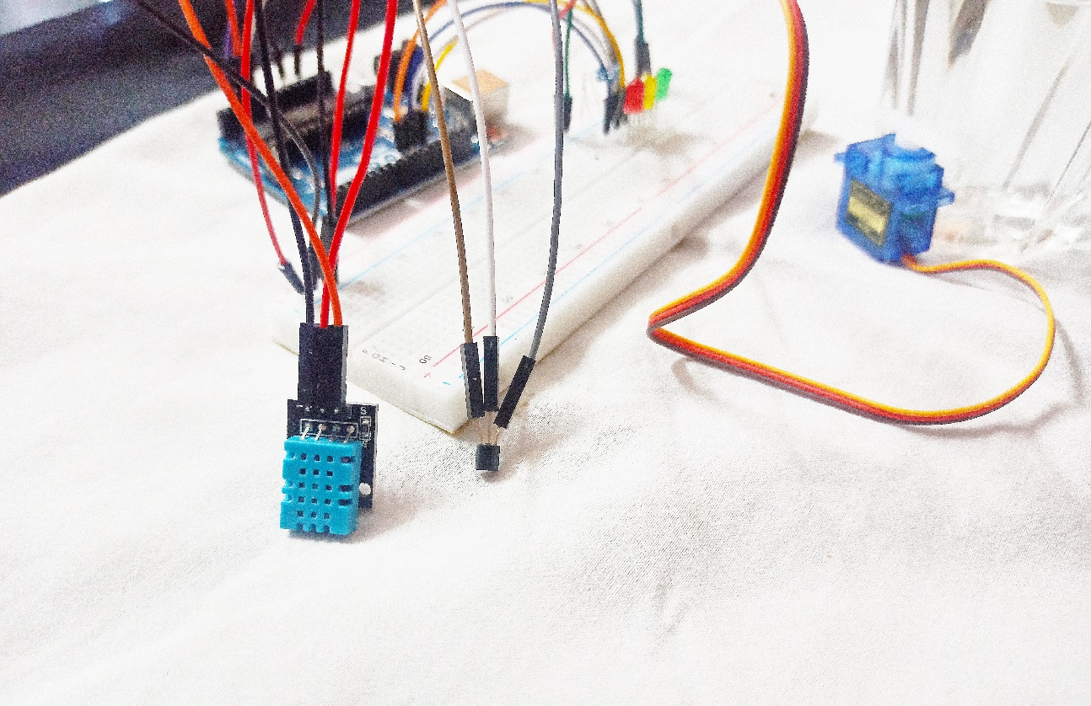

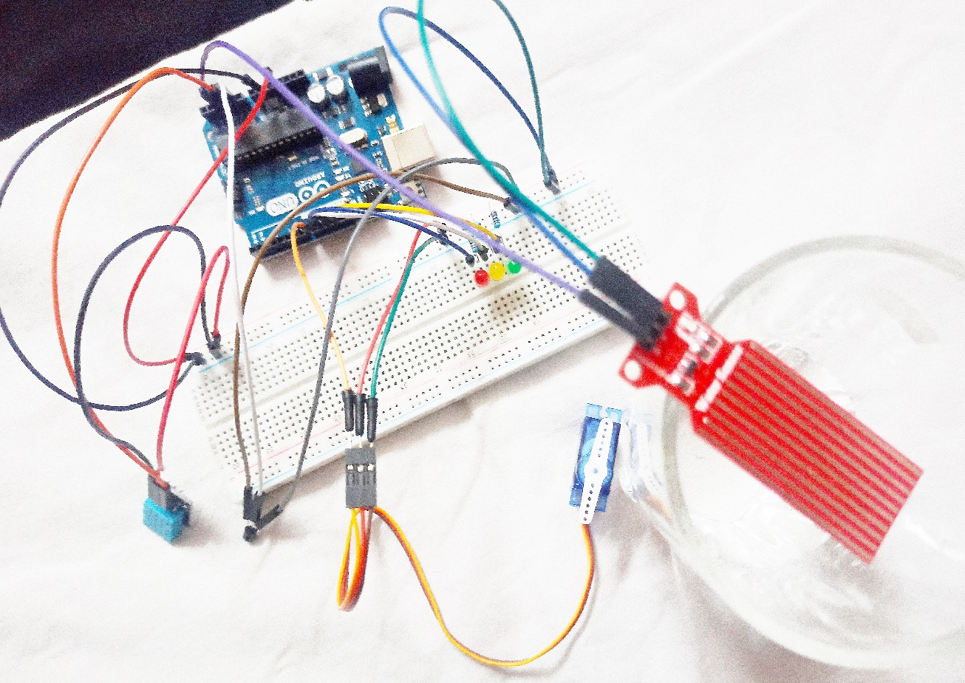

**CHAPTER 4**

**CONCLUSION**

**4.1 SUMMARY**

The objectives have been formulated as the working basis on completion of the study. The general objective of the researchers was attained which the developed system is entitled “Flood Detector System using Arduino” which will gradually help commuters to avoid getting stuck along the way. It will help the commuters to save money, time, and effort. The Flood Detector System using Arduino was developed to be one of the fastest methods to check and monitor the flood.

**4.2 CONCLUSION**

The study is all about detecting the level of the flood. Marulas, researchers have concluded that the Flood Detector System using Arduino can measure the height of the flood; and measurement data can be distributed to officer in charge and to the residents. The system also indicate passable and impassable road that will help commuters to avoid getting stuck in an impassable road. The system also provides camera to easily monitor the flood.

**4.3 FUTURE WORKS**

Sensors are important elements in the Flood Observatory System. Further studies on wireless sensor technology will be best to replace the current sensors. Precise and accurate detection of water level will improve the data collection system for the monitoring station.

The flood alert information’s can be displayed on LED display boards for road users and for safety reasons could be placed at strategic locations. Such information’s should be in real time and transmitted wirelessly from the measured location.

A possible means of power supply for the sensors and centralised control unit is via solar cells. The Flood Observatory System will be easy to install and maintained if it is powered by solar cells. The use of solar energy will also provide cheaper source of power to the entire system to operate especially if the system is placed in a remote location. For sustainability the circuits and control unit should be designed to consume minimum power during operation.

**APPENDIX**

**CODE**

#include<Servo.h>

#include "DHT.h"

#define dht_apin A2

#define DHTTYPE DHT11

Servo servoobject;

DHT dht(dht_apin, DHTTYPE);;

int tempPin = A1;

int senseInput;

int reading;

float voltage,temperatureC,temperatureF;

int led1 = 9;

int led2 = 10;

int led3 = 11;

int i;

void setup() {

Serial.begin(9600);

Serial.println("DHTXxx test!");

dht.begin();

pinMode(led1, OUTPUT);

pinMode(led2, OUTPUT);

pinMode(led3, OUTPUT);

servoobject.attach(8);

}

void loop() {

tempPin = analogRead(A1);

int reading = analogRead(tempPin);

float voltage = reading * 5 / 1024;

float temperatureC = (voltage) * 100;

float temperatureF = (temperatureC*9/5)+32;

Serial.print("Current Temperature: ");

dht.read(dht_apin);

Serial.print("Current Humidity");

Serial.print(dht.readHumidity());

Serial.print("%");

delay(5000);

int value = analogRead(A3);

if(value > 500) {

Serial.println("Very Heavy Rain");

digitalWrite(led1, HIGH);

digitalWrite(led2, LOW);

digitalWrite(led3, LOW);

for( i = 0; i <= 360; ++i)

{

servoobject.write(i);

}}

else if((value > 300) && (value <= 500)) {

Serial.println("Average Rain");

digitalWrite(led2, HIGH);

digitalWrite(led3, LOW);

for( i = 360; i >= 0; --i)

{

servoobject.write(i);

} }

else{

Serial.println("Dry Weather");

digitalWrite(led3, HIGH);

digitalWrite(led1, LOW);

digitalWrite(led2, LOW);

for( i = 0; i <= 360; ++i)

{

servoobject.write(i);

delay(15);

}

for( i = 360; i >= 0; --i)

{

servoobject.write(i);

delay(15);

}}

**REFERENCES**

1. Warren, J., Adams, J., and Mole, H. Arduino Robotics
2. Hughes, C., Hughes, T., Watkins, T. and Kramer, B., Teams of Robotics with Lego Mindstorms NXT & Bluetooth
3. DIAD ALERT real-time weather monitoring and flood warning. DIAD Incorporated, 20 September 2000
4. Gerardo Di Martino, Antonio Iodine, Daniele Riccio and Giuseppe Remo, A Novel Approach for Disaster Monitoring: Fractal Models and Tools, IEEE Transactions on Geoscience and Remote Sensing
5. AT Commands Interface Guide, Wave com, 2002, pp. 2-13